Session 2026-2027

Vision:Dream of where you want. | Mission: Means to achieve Vision

Program Educational Objectives of the program (PEO): (broad statements that describe the professional and career accomplishments)
PEO1 | Preparation | P: Preparation | Pep-CL abbreviation  pronounce as Pep-si-lL easy to recall
PEO2 | Core Competence | E: Environment (Learning Environment) | Pep-CL abbreviation  pronounce as Pep-si-lL easy to recall
PEO3 | Breadth | P: Professionalism | Pep-CL abbreviation  pronounce as Pep-si-lL easy to recall
PEO4 | Professionalism | C: Core Competence | Pep-CL abbreviation  pronounce as Pep-si-lL easy to recall
PEO5 | Learning Environment | L: Breadth (Learning in diverse areas) | Pep-CL abbreviation  pronounce as Pep-si-lL easy to recall

Program Outcomes (PO): (statements that describe what a student should be able to do and know by the end of a program)
Keywords of POs:
Engineering knowledge,Problem analysis, Design/development of solutions,Conduct Investigations of Complex Problems, Engineering Tool Usage, The Engineer and The World,Ethics, Individual and Collaborative Team work,Communication, Project Management and Finance, Life-Long Learning

PSO Keywords: Cutting edge technologies, Research

“I am an engineer, and I know how to apply engineering knowledge to investigate, analyse and design solutions to complex problems using tools for entire world following all ethics in a collaborative way with proper management skills throughout my life.” to contribute to the development of cutting-edge technologies and Research.

Integrity: I will adhere to the Laboratory Code of Conduct and ethics in its entirety.

Name and Signature of Student and Date
(Signature and Date in Handwritten)

Session | 2026-27 (ODD) |  | Course Name | Web Technology Lab
Semester | 3 |  | Course Code | 23CT1301
Roll No | 65 |  | Name of Student | Shubham Dnyaneshwar Umredkar
Practical Number |  | 4A
Course Outcome |  | - Understand various internet technologies.  - Design the web pages using HTML and CSS.  - Implement the XML technology to store the data.  - Develop the interactive web pages using JavaScript.
Aim |  | Introduction to JavaScript (Loop, Conditional Statement)
Problem Definition |  | Build a registration form (name, email, password, phone number) and write JavaScript to validate all fields on submit, displaying inline error messages
Theory  (100 words) |  | JavaScript is a scripting language used to make web pages interactive and dynamic. Conditional statements such as if, else if, and else are used to make decisions based on different conditions. Loops such as for, while, and do-while are used to repeat a block of code multiple times. Form validation is used to check whether the information entered by the user is correct before submitting the form. JavaScript can validate fields such as name, email, password, and phone number. If any field contains invalid or empty data, an error message is displayed near that field for the user.
Procedure and Execution  (100 Words) |  | Step for Implementation:  - Create an HTML registration form with Name, Email, Password, and Phone Number fields.  - Add a Submit button to the form.  - Give each input field a unique id so JavaScript can access it.  - Create separate elements for displaying inline error messages.  - Write a JavaScript function that runs when the form is submitted.  - Get the values entered in all input fields.  - Use conditional statements to check whether any field is empty or invalid.  - Validate the email format, password length, and phone number.  - Display an error message beside incorrect fields.  - Submit the form only when all entered information is valid.
Code:
Html:
<!DOCTYPE html>
<html lang="en">
<head>
<meta charset="UTF-8">
<meta name="viewport" content="width=device-width, initial-scale=1.0">
<title>Computer Student Registration Form</title>
<link rel="stylesheet" href="Practicle_4.css">
</head>
<body>

<div class="container">
<form onsubmit="return validateForm()" id="studentForm">
<h2>Computer Science Student Registration</h2>

<div class="input-box">
<label>Full Name</label>
<input type="text" id="name" placeholder="Enter your name">
</div>

<div class="input-box">
<label>Roll Number</label>
<input type="text" id="roll" placeholder="Enter Roll Number">
</div>

<div class="input-box">
<label>Email</label>
<input type="email" id="email" placeholder="Enter Email">
</div>

<div class="input-box">
<label>Mobile Number</label>
<input type="tel" id="mobile" placeholder="Enter Mobile Number">
</div>

<div class="input-box">
<label>Date of Birth</label>
<input type="date" id="dob">
</div>

<div class="input-box">
<label>Gender</label><br>

<label><input type="radio" name="gender" value="Male"> Male</label>

<label><input type="radio" name="gender" value="Female"> Female</label>

<label><input type="radio" name="gender" value="Other"> Other</label>
</div>

<div class="input-box">
<label>Department</label>

<select id="department">
<option value="">Select Department</option>
<option>Computer Technology</option>
<option>Computer Engineering(IOT)</option>
<option>Computer Engineering</option>
<option>Information Technology</option>
<option>Artificial Intelligence</option>
<option>Data Science</option>
<option>Cyber Security</option>
</select>
</div>

<div class="input-box">
<label>Semester</label>

<select id="semester">
<option value="">Select Semester</option>
<option>Semester I</option>
<option>Semester II</option>
<option>Semester III</option>
<option>Semester IV</option>
<option>Semester V</option>
<option>Semester VI</option>
</select>
</div>

<div class="input-box">
<label>Programming Languages</label><br>

<label><input type="checkbox"> C</label>
<label><input type="checkbox"> C++</label>
<label><input type="checkbox"> Java</label>
<label><input type="checkbox"> Python</label>
<label><input type="checkbox"> JavaScript</label>
</div>

<div class="input-box">
<label>Address</label>
<textarea id="address" rows="4"></textarea>
</div>

<div class="input-box">
<label>Password</label>
<input type="password" id="password">
</div>

<div class="input-box">
<label>Confirm Password</label>
<input type="password" id="confirmPassword">
</div>

<button type="submit">Register</button>

</form>
</div>

<script src="Practicle_4.js"></script>

</body>
</html>
Javascript:

function validateForm(){
let name = document.getElementById("name").value.trim();
let roll = document.getElementById("roll").value.trim();
let email = document.getElementById("email").value.trim();
let mobile = document.getElementById("mobile").value.trim();
let department = document.getElementById("department").value;
let semester = document.getElementById("semester").value;
let password = document.getElementById("password").value;
let confirmPassword = document.getElementById("confirmPassword").value;

if(name==""){
alert("Please enter your name.");
return false;
}

if(roll==""){
alert("Please enter Roll Number.");
return false;
}

if(email==""){
alert("Please enter Email.");
return false;
}

if(mobile.length!=10){
alert("Mobile number should contain 10 digits.");
return false;
}

if(department==""){
alert("Select Department.");
return false;
}

if(semester==""){
alert("Select Semester.");
return false;
}

if(password.length<6){
alert("Password must contain at least 6 characters.");
return false;
}

if(password!==confirmPassword){
alert("Passwords do not match.");
return false;
}

alert("Registration Successful!");
return false;
}
CSS :
body {
font-family: Arial, sans-serif;
background-color: #f2f2f2;
}

form {
width: 400px;
margin: 30px auto;
background-color: white;
padding: 20px;
border: 1px solid black;
}

h2 {
text-align: center;
}

label {
font-weight: bold;
}

input,
select,
textarea {
width: 100%;
padding: 8px;
margin-top: 5px;
box-sizing: border-box;
}

input[type="radio"],
input[type="checkbox"] {
width: auto;
}

button {
padding: 10px 20px;
background-color: blue;
color: white;
border: none;
cursor: pointer;
}

button:hover {
background-color: darkblue;
}

Output:
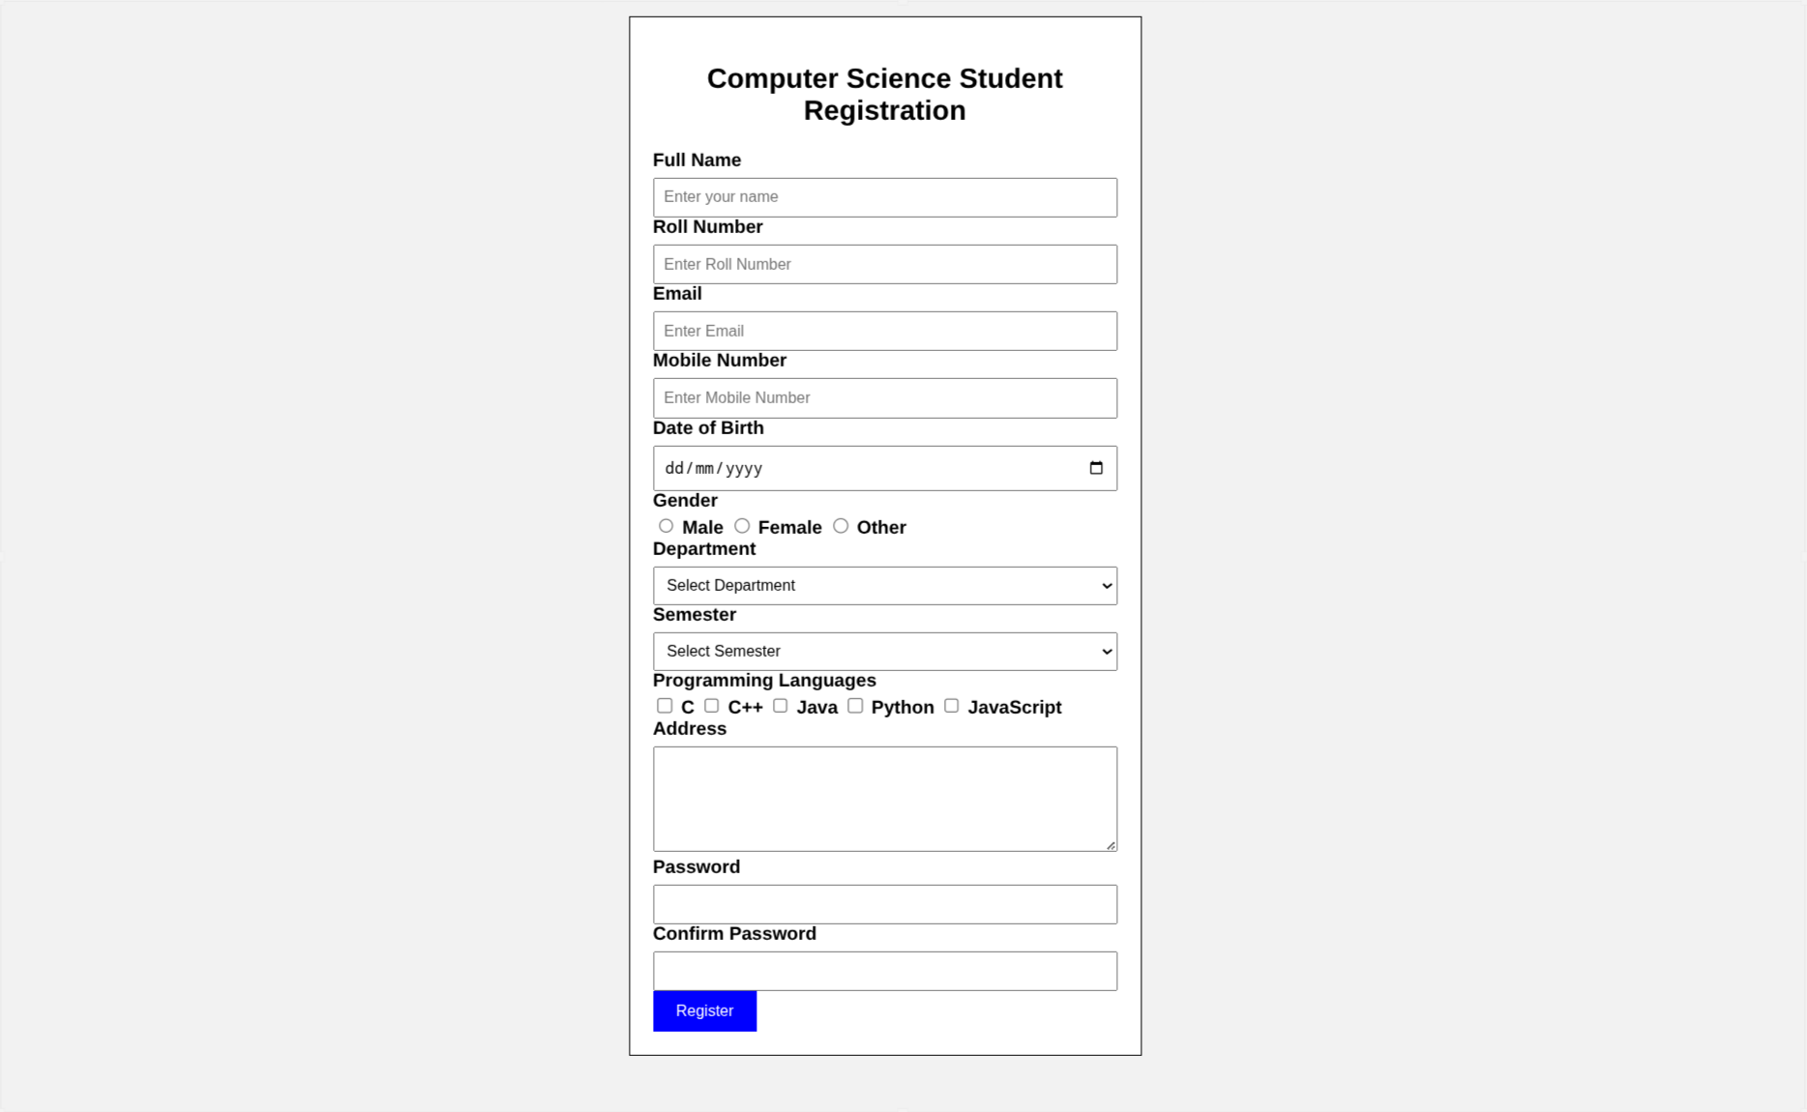
Output Analysis |  | The registration form accepts student details such as name, roll number, email, mobile number, department, semester, password, and other information. When the user clicks the Register button, JavaScript checks the entered values. If any required field is empty or contains incorrect data, an alert message is displayed. The mobile number must contain 10 digits and the password must contain at least 6 characters. The password and confirm password must also match. If all details are entered correctly, the message “Registration Successful!” is displayed. Thus, JavaScript helps validate user input before form submission.
Link of student Github profile where lab assignment has been uploaded |  | https://github.com/shubham07-codes/Web-Technology-Lab
Conclusion |  | This practical helped us understand the basic use of JavaScript for form validation. We learned how to use conditional statements, loops, input fields, and validation checks in a registration form. JavaScript checks the user-entered data before submission and displays appropriate alert messages when the input is invalid. It also helps ensure that details such as mobile number, password, and other fields are entered correctly. Therefore, JavaScript form validation improves the accuracy of data and makes web forms more reliable and user-friendly.
Plag Report (Similarity index < 12%)
Date |  | 11-08-2026

